## Skill-React

**React Hands-on Lab: Student Score Calculator**

# Code:

## Terminal Instructions:

**# 1. Create a new React project**

**npx create-react-app scorecalculatorapp**

**# 2. Navigate into the project directory**

**cd scorecalculatorapp**

**# 3. Open the project in Visual Studio Code**

**code .**

**# 4. Start the React development server**

**npm start**

# Codes:

## CalculateScore.js:

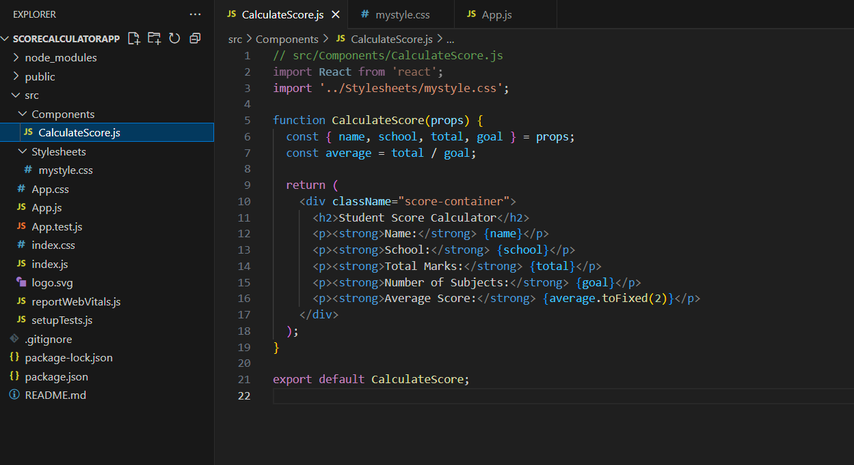

## mystyle.css:

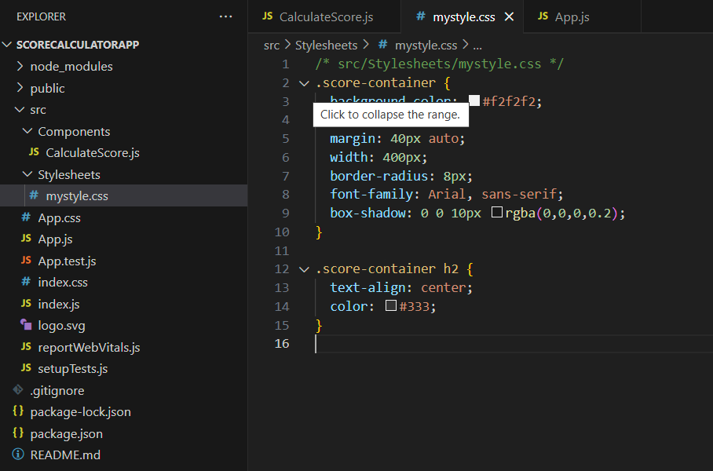

## App.js:

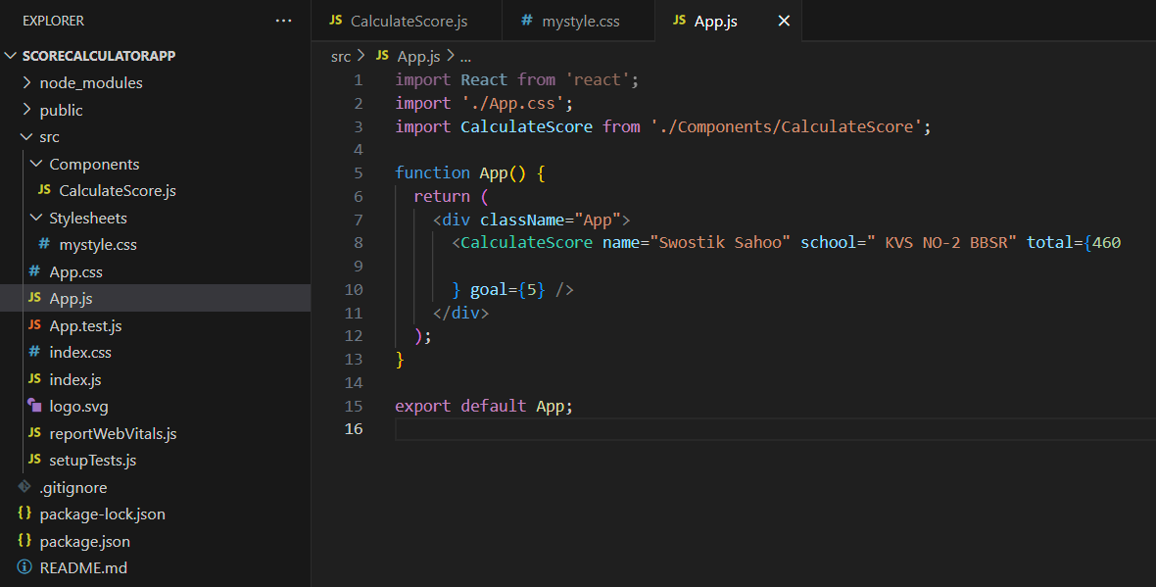

# Output:

